Magball rod modification process
If you’ve given up on the stock arms becoming loose or producing bad prints because the fisheyes break down, you may wish to contact anycubic (if you’re under warranty) to get new ones sent to you. But if you’re out of warranty or you wish for a more permanent solution. Magball arms are a very good replacement that does away with the need for elastics or springs to keep the arms even and not slipping.
The process for replacing your stock fisheye rods with Haydn Huntleys magball rods is fairly simple. If you plan to do this with a smart effector another tutorial will need to be made as this one deals with replacing the rods with the stock effector with no other modifications required.

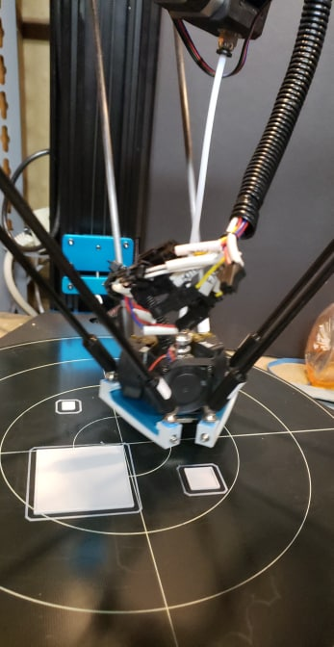 stock effector with magball rods

Needed:

- 440mm rods from Haydn Huntley - https://www.magballarms.com/. Let him know it is for this tutorial and you want the 440 rods for the Anycubic predator (D)
- Another printer or previously printed versions of the carriage adapter (3 each) and the effector spar holders (3 each) stl’s attached to this document.
- 6 m3 x 16 screws or the original ones that are on the fisheye bushings
- 6 m3 nuts for the carriage side magspars
- 6 m4 nuts to act as spacers under the effector side magspars
Various tools for installation

The important part to ensure proper operation of the delta is to maintain a parallel distance between rods from carriage straight through to effector. Failure to maintain this distance will result in poor quality and potentially dropping your effector due to improper motion.
The carriage side and effector side adapters for the magspars are designed to keep a parallel distance so it should be easy to maintain.

Remove the effector from the stock rods and remove the rods from the carriage ends as well.
Prepare the new carriage side magball spar adapter by inserting the magspars and securing with m3 nuts
Remove the carriage side rod connection block and replace with the new magball spar carriage adapters (printed) (use existing m5 screws to attach new one)

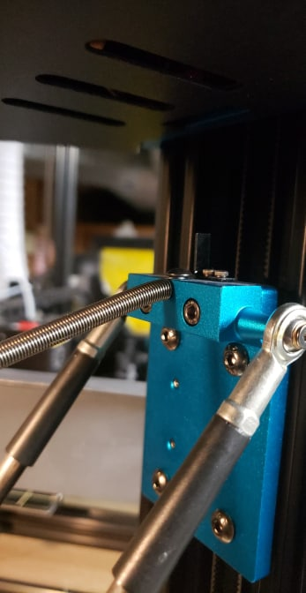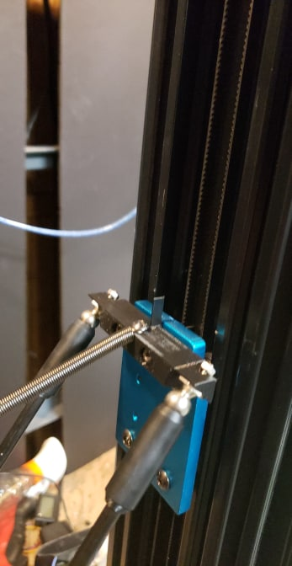
Old carriage with fisheye adapter carriage with magspar adapter

Prepare the effector side magspar adapters by starting screws through side holes and attach to the 3 effector arms with the top hole pointing upwards and the bracing under the effector. (use new m3x16 screws or the old ones from the fisheye connections)
Slip a m4 nut on each magspar and screw them into the 6 holes on top of the magspar adapters like the picture below. You need to slip the m4 nut in there is because the magspar screws cannot go in all the way before they crash into the screws holding the mounts to the effector.
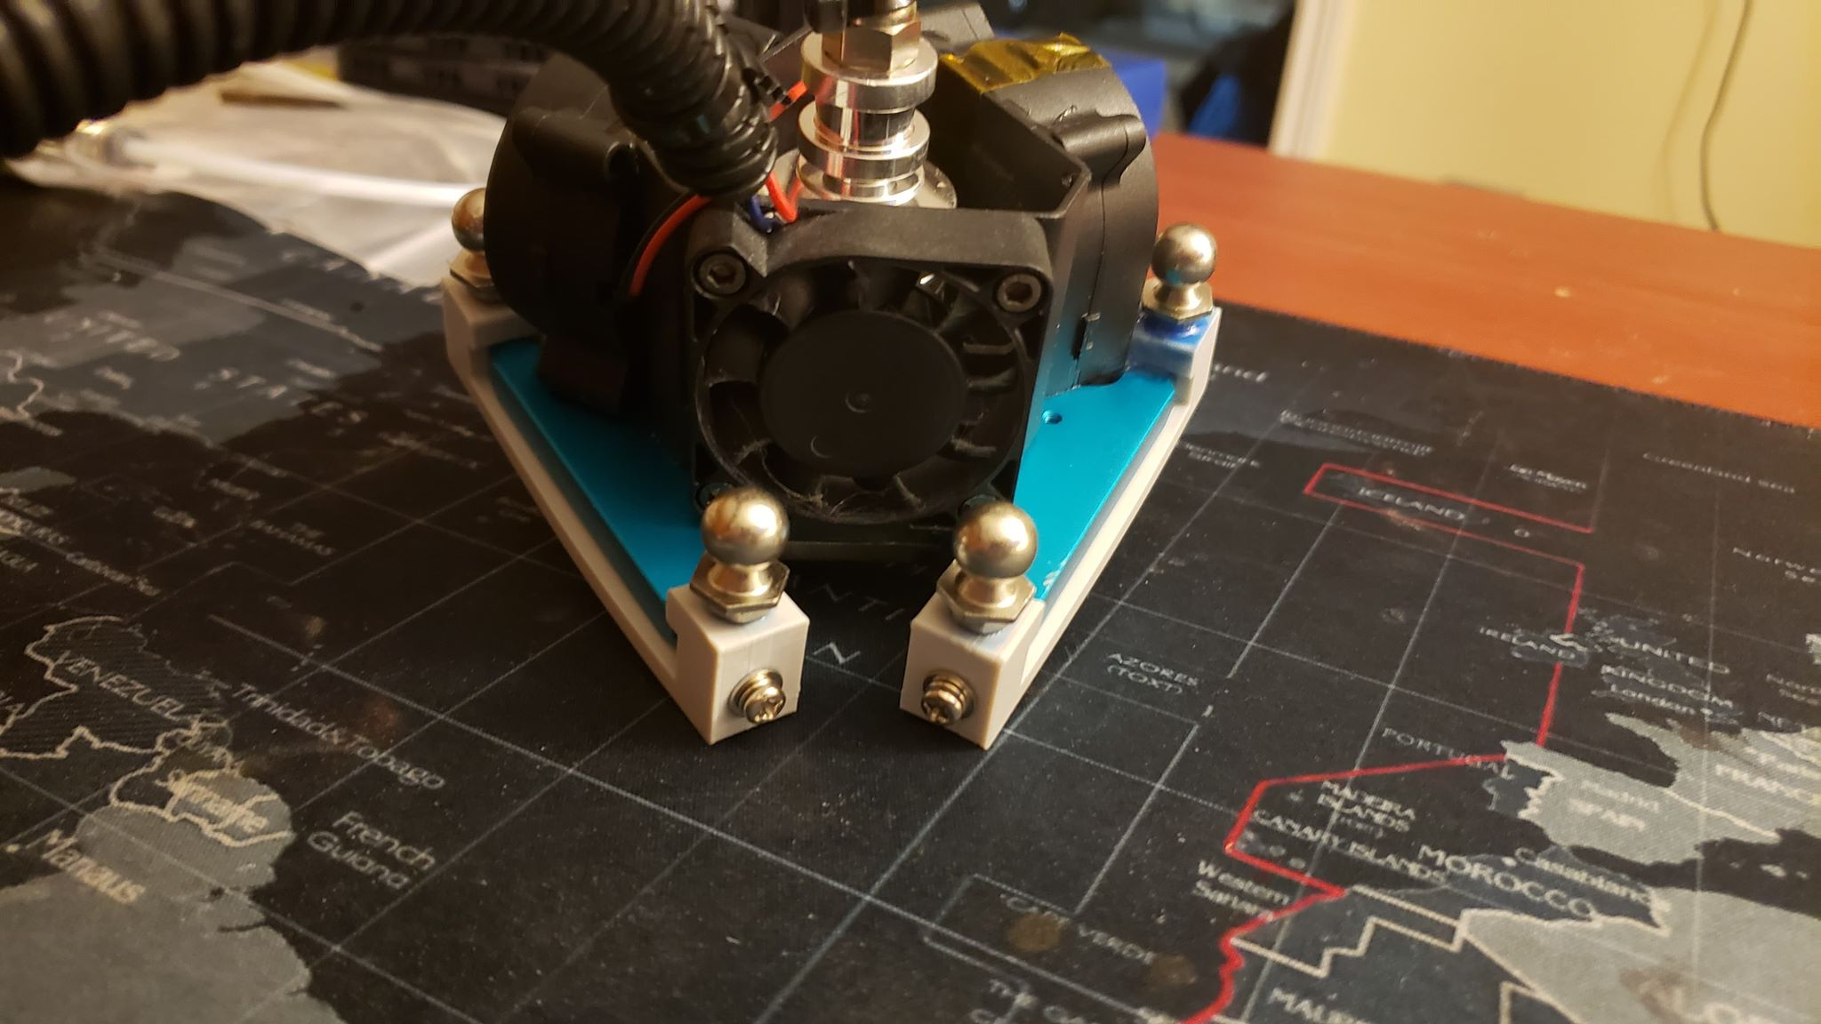
*note I have replaced the stock 4010 fan swith 4020’s so space is of a premium. If you wish to modify the magspar adapters because you have the 4010’s, feel free to modify them to suit your needs.
Once you’ve secured everything, you can reinstall the effector into the printer with the magrods.

Important step now is to program the printer with your new magball rod lengths.

Haydn kindly writes on stickers the rod length but it is not enough to use that value. Both the carriage side and effector side magball spars add additional length to the arms. I’ve measured between 22 and 24 mm is added from the 440mm written so I would suggest trying the 24 first and then drop down to 22 if your prints are not dimensionally correct (I am including a series of 10, 20,40,60mm cubes you can print out and measure x y z dimensional consistency, or you can use whatever other method you wish to judge the accuracy of dimensions)

So magball rods in my case were 440.46mm + 24mm for the magspars for a total of 464.46mm
Connecting through pronterface or Octoprint you can send this command to the printer to tell it what the new rod lengths are.
M8083 S464 where M8083 is the chitu code to tell the printer rod length and S464 is the length in mm of your rods.
Run a M8500 to save the values and then perform a leveling of the printer as you would normally.
At this time you can print out the dimensional tests and if necessary adjust your M8083 values up or down to get your dimensions as close as possible.

Feel free to contact me if you have additional questions or this tutorial needs to be updated.
https://www.facebook.com/john.giardino.98

STL files used in this tutorial:

Magspar holder (effector side)

Magspar holder (carriage side)

Dimensional cubes

All files in Rar format

